EwE MPA dynamics plug-in
- a brief users’ guide


Version 1, 21 February 2024
Compatible with Ecopath with Ecosim version 6.7 α1
Marta Coll, Jeroen Steenbeek
Ecopath International Initiative, Spain
https://doi.org/10.6084/m9.figshare.XXXXXXX

Contents
Scope and purpose 2
Acknowledgements 2
Summary 3
Implementation 3
Launching the plug-in 3
Modifying the MPA enforcement CSV file 4

Scope and purpose
This document provides usage instructions for the MPA Dynamics plug-in to the Ecopath with Ecosim food web modelling approach (Christensen and Walters, 2004; Heymans et al., 2016). If you have any questions, find bugs, or see ways to expand on this functionality please contact us at ewedevteam@gmail.com.
This document was last updated February 2024 to EwE version 6.7.0.18702 prerelease.

Acknowledgements
MPA dynamics was implemented by Jeroen Steenbeek and Marta Col after an idea by Colette Wabnitz.

Summary
Ecospace, the spatial-temporal module of the Ecopath with Ecosim (EwE) approach, offers the ability to define fisheries restricted areas. In the software, these areas are referred to as MPAs, and are used to block out fishing from specific Ecospace cells for a given fleet and a given month. MPA maps can overlap in space, thus allowing the user to apply different enforcement rules in a single cell. This provides a powerful mechanism to restrict fisheries across space.
A shortcoming of the EwE approach is a limited inability to alter fishing enforcement over time once a simulation is in progress. Whereas the spatial temporal data framework can be used to alter the maps of each MPA, thus varying where a given fisheries enforcement takes place, the EwE software does not offer the means to change the type of enforcement of MPAs once a simulation has started. This means that Ecospace could not be used to assess the impacts of changing MPA enforcement at any point in time other than the Ecospace start year.
To overcome this limitation, the MPA Dynamics plug-in was conceptualized.

Implementation
In Ecospace, each MPA has three configurable sets of parameters: i) a monthly pattern that states whether the MPA is open or closed, ii) a table that defines which fleets that are banned from fishing in each MPA; and iii) the map cells to which restrictions applies. MPAs can spatially overlap (Figure 1).
The spatial temporal data framework (Steenbeek et al., 2013) can be used to change the spatial layout of each MPA. The MPA Dynamics plug-in, installed with EwE 6.6.6 and newer, now also provides a mechanism for changing the months that an MPA is open or closed, and which fleets are banned from fishing under a given MPA, at any point in time.
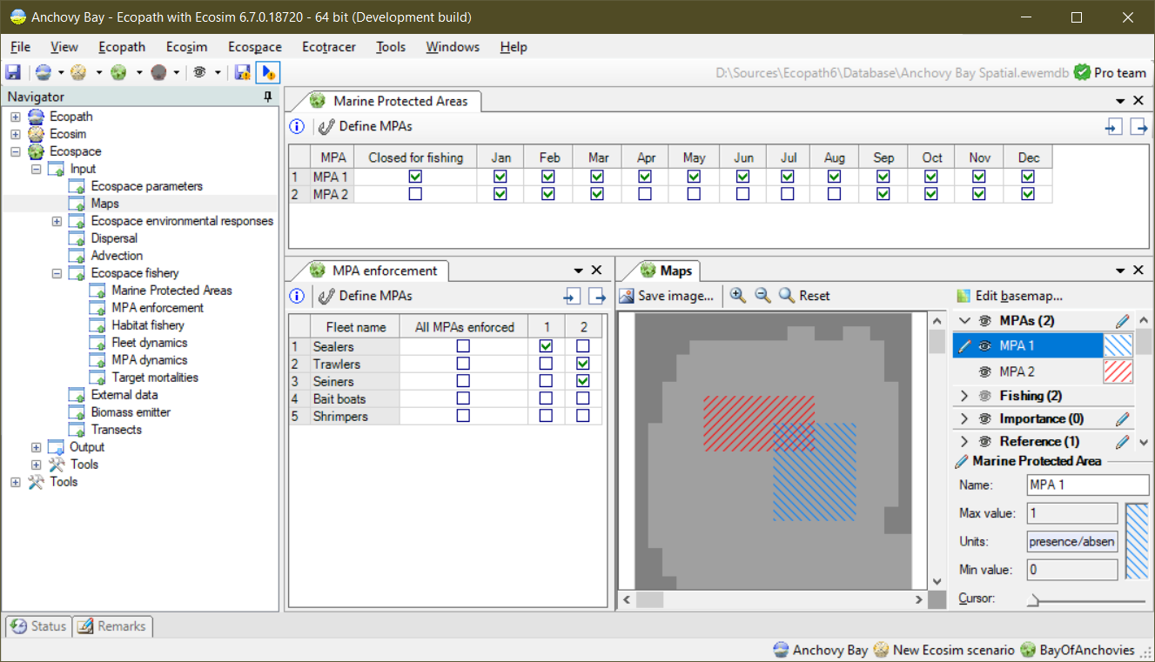
iii
ii
i
Figure 1 - MPA parameterization in the Ecospace interface: i) the monthly pattern of MPA closures; ii) MPA enforcement; and iii) the maps that indicate where the different MPAs are located. As shown here, MPAs can overlap.

Launching the plug-in
The plug-in can be accessed from “EwE > Navigator > Ecospace > Input > Ecospace fishery > MPA Dynamics”, and brings up the interface as shown in Figure 2.
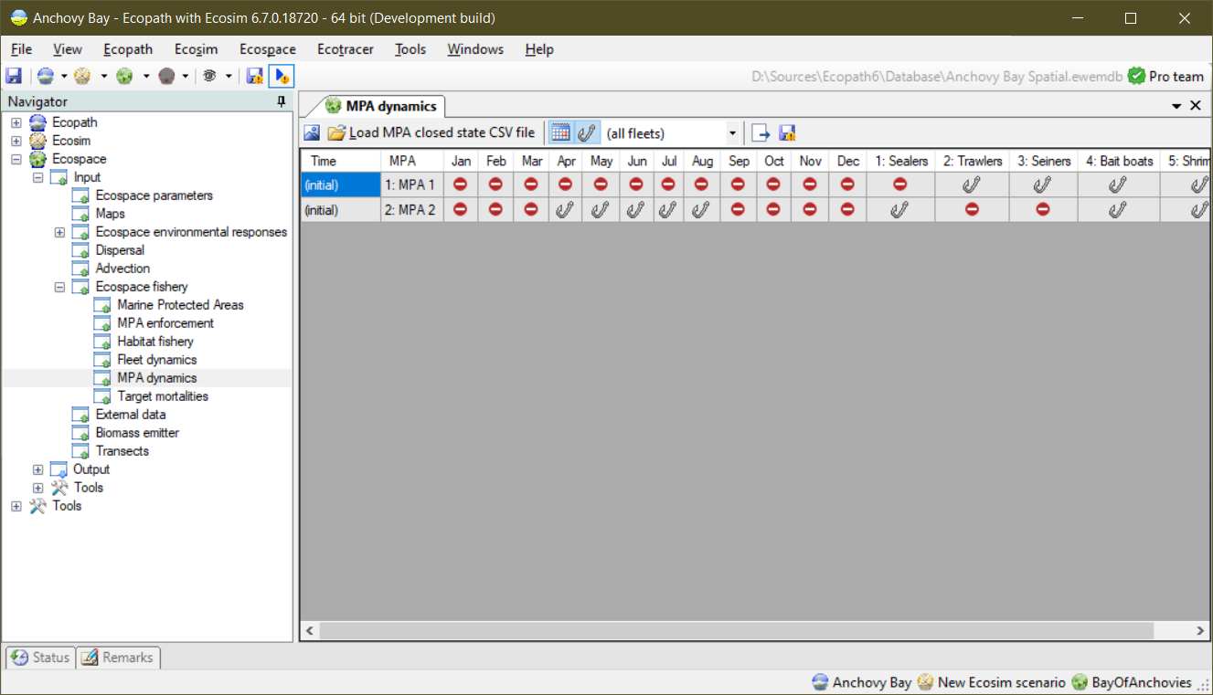
Figure 2 - MPA Dynamics interface with a control toolbar and a data grid. Here, the data grid reflects the MPA enforcement configuration from Figure 1. At the initial Ecospace time step, “MPA 1” is closed all year and only affects fleet “1: Sealers”. “MPA 2” is only open April-August and only affects fleets “2: Trawlers” and “3: Seiners”.
The plug-in has the following components:
- A toolbar to control the functioning of the plug-in, with the following options from left to right:
  - “Export to CSV file”. This option will write out the MPA configuration state in Ecospace to a CSV file, which functions as a foundation for creating the MPA Dynamics CSV file (see section “Modifying the MPA enforcement CSV file”), below.
  - “Load MPA closed state CSV file”. This option will load the CSV file with changes to MPA enforcement into the MPA Dynamics plug-in;
  - Two filter buttons “Show months” and “Show fleets”, along with a fleet selection combo box. These options serve to limit the columns to show in the MPA Dynamics data grid (see below);
  - “Run with Ecospace”. This option enables or disables whether the MPA Dynamics plug-in runs with Ecospace.
  - “Autosave closure statistics”. This option toggles whether the plug-in should write out a CSV file that states when and how MPA enforcements were changed. This file is meant for you, the user, to check and troubleshoot if the MPA Dynamics plug-in is applying changes as intended.
- A data grid that shows the start-up MPA enforcement configuration in Ecospace, and if CSV file has been loaded, the grid shows for which time steps which configuration changes will be applied.

Modifying the MPA enforcement CSV file
Please do the following to generate the blueprint CSV file:
- Have your Ecospace model loaded and your MPA(s) configured and ready
- Launch the MPA Dynamics plug-in from “EwE > Navigator > Ecospace > Input > Ecospace fishery > MPA Dynamics”
- Observe that the initial MPA enforcement state is correctly reflected in the data grid.
- Export the initial MPA enforcement state to a CSV file by clicking “Export to CSV file”.
- You will be asked to browse to a folder where to store the file, and how to name it. Do so, and close the pop-up.
- The EwE status panel will now show you where the file was saved.
Now, open the file that you just saved in Excel or an equivalent, and add rows. The following rules apply:
- Each row must provide values for the first two columns:
- Column 1 “Timestep” = the one-based timestep when the change is to take place
- Column 2, “MPA” = the number of the MPA affected by the change
- Columns 3-15, named “mX” where X is a number from 1-12, indicate the months that the MPA is enforced.
- Columns 16 and onward are for the fleets defined in your model, with each fleet its own column.
- For every row that you add past time step 1, values for columns 1 and 2 MUST be provided. Cells for all the other columns can be
  - left empty (e.g., nothing changes)
  - set to “1” or “y” to turn ON enforcement for a given column
  - set to “0” or “n” to turn OFF the enforcement in a given column.

Consider, for instance, the following example CSV file:
Table 1 – An Excel snapshot of a sample CSV file that change enforcement of MPA 1
Timestep | mpa | m1 | m2 | m3 | m4 | m5 | m6 | m7 | m8 | m9 | m10 | m11 | m12 | fleet1 | fleet2 | fleet3 | fleet4 | fleet5
1 | 1 | 1 | 1 | 1 | 1 | 1 | 1 | 1 | 1 | 1 | 1 | 1 | 1 | 1 | 0 | 0 | 0 | 0
1 | 2 | 1 | 1 | 1 | 0 | 0 | 0 | 0 | 0 | 1 | 1 | 1 | 1 | 0 | 1 | 1 | 0 | 0
25 | 1 |  |  | 0 |  |  |  |  |  | 0 |  |  |  |  |  |  | 1

In the CSV file (Table 1) shows the Ecospace start-up situation for MPAs 1 and 2, and adds one line with changes in the enforcement of MPA 1. At time step 25 (January of simulation year 3), MPA 1 will no longer be in force for months 3 and 9, effectively opening the MPA for fishing for March to September. However, the MPA will from time step 25 onward also be applicable to fleet 4, which can now no longer fish in MPA 1 alongside fleets 2 and 3.

Table 2, below, will have the same effect when loaded in the MPA Dynamics, but some users may prefer not to leave any columns empty:

Table 2 - The same data as shown in Table 1, but with all cells filled
Timestep | mpa | m1 | m2 | m3 | m4 | m5 | m6 | m7 | m8 | m9 | m10 | m11 | m12 | fleet1 | fleet2 | fleet3 | fleet4 | fleet5
1 | 1 | 1 | 1 | 1 | 1 | 1 | 1 | 1 | 1 | 1 | 1 | 1 | 1 | 1 | 0 | 0 | 0 | 0
1 | 2 | 1 | 1 | 1 | 0 | 0 | 0 | 0 | 0 | 1 | 1 | 1 | 1 | 0 | 1 | 1 | 0 | 0
25 | 1 | 1 | 1 | 0 | 0 | 0 | 0 | 0 | 0 | 0 | 1 | 1 | 1 | 0 | 1 | 1 | 1 | 0

Once you are happy with the temporal changes that you wish to apply to Ecospace, do the following:
- Save the CSV file and, if you are using Excel, close Excel to free the file for further use,

Running the MPA Dynamics
To make the MPA Dynamics work, do the following:
- In the MPA Dynamics tool, click “Load MPA closed state CSV file”
- Browse to the file that you just edited, and load it
- The MPA Dynamics grid should now show you the new rows that you added

To run the new data through the MPA Dynamics plug-in, do the following:
- Ensure that the MPA Dynamics plug-in is active by pressing the “Run with Ecospace” option. It will stay depressed to indicate it is active.
- Now start an Ecospace run as you normally do. The plug-in will integrate in the Ecospace flow.
- Whenever the MPA Dynamics makes a change to enforcement, it will notify the user in the EwE status panel.

